Sorting Algorithms Time Graphs:

As you can see in the graphs, quicksort very quickly takes upwards of 2 minutes for an input size of 200,000 which only increases exponentially as time goes on. Merge sort on the other hand can take an input size of 1,000,000 before needing upwards of 2 minutes. Mergesort, just purely by its design of dividing our problem up is magnitudes less expensive than our quicksort algorithm.
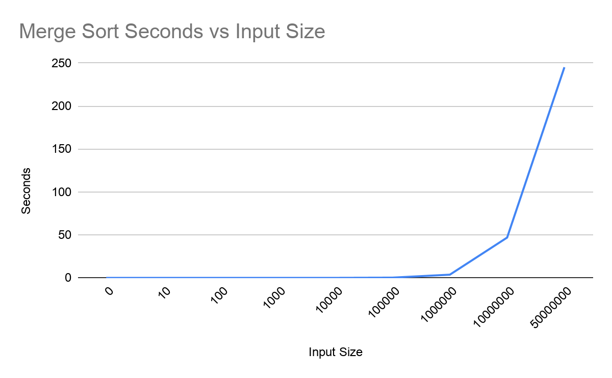
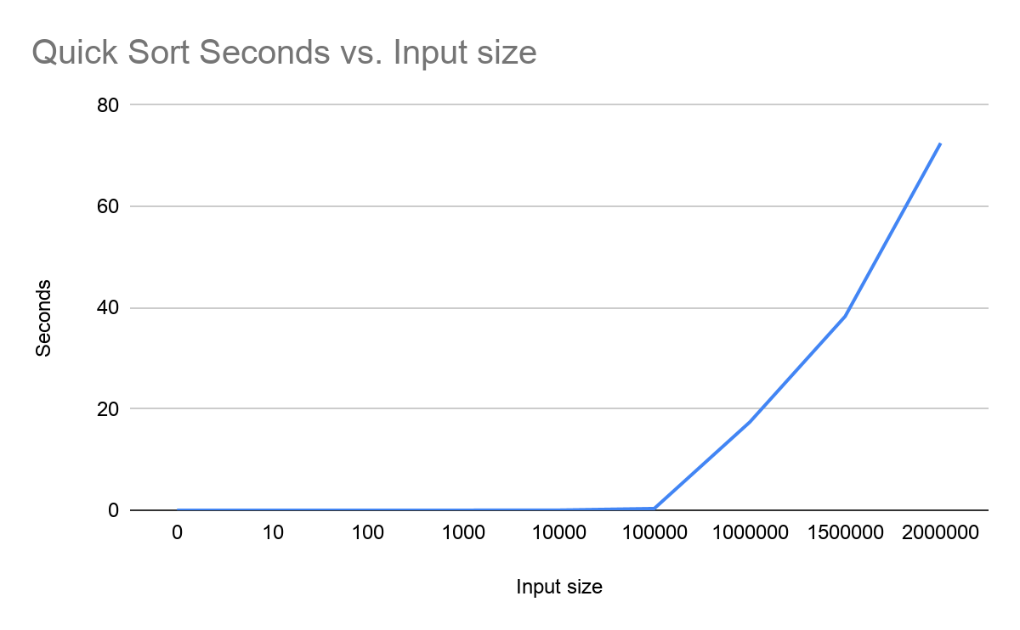
In the graphs above you can see just how the efficiency of merge sort pans out over time in accordance with our expected results. While at input sizes under 100,000 the time to finish the problem is roughly the same at under 5 seconds the difference becomes noticeable as quick sort begins to suffer under the load of a large array size that it needs to check. Merge sort, on the other hand, continues to finish the problem in under 5 seconds at the same input sizes. It is only merge sort reaches 10,000,000 that it begins to take more than 10 seconds.

Towers of Hanoi:
Recurrence Relation:

When calculating the recurrence relationship we are looking at how many “moves” the computer must take for that many discs it has originally.
Due to the rules of the game moving a disc around becomes a recursive formula where upon you must use the spare peg to avoid putting a bigger disk on top of a smaller one. In moving n discs around it becomes an M(n-1) with base base M(1)=1.Then we must move our last disc to the final tower. Finally we repeat our earlier actions and move the rest of the discs to their final tower.

We see that for the following M(x) we get this many moves before we win:
M(1)=1
M(2)=2M(1) + 1=3
M(3)=2M(2) + 1=7
M(4)=2M(3) + 1=15
M(5)=2M(4) + 1=31
Or generally: M(n) = 2M(n)+1

Finding the closed form:
M(n-1)=2M(n-1)+1
M(n-2)=2M(n-2)+2

Which shows 2(2(M(n-2)+1)+2
We want this in terms of our base condition to find the closed form so:
M(n-k)=$\left(2^{k}\right)∗M\left(n−k\right)+\left(2^{k}\right)−1$
n-k=1
k=n-1
T(1)=1
=$2^{n−1}T\left(1\right)+2^{n−1}−1$
=$2∗2^{n−1}−1$
T(n) =$2^{n}−1$
From this we can see the time complexity is O(2^n)

Graph of actual time complexity:

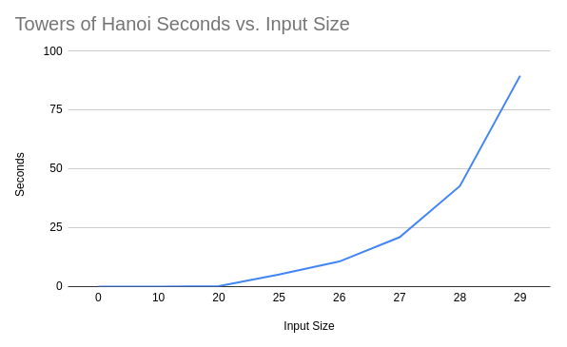

(matrix multiplication results on next page)

Matrix Multiplication:

Similar to our sorting algorithms, a huge increase in efficiency was noticed when we divided our problem up using Strassen’s Method. Where classical matrix multiplication took upwards of a minute for a matrix less than 1,000x1,0000, Strassens took less than 10 seconds to do a matrix of 1,000x1,000.

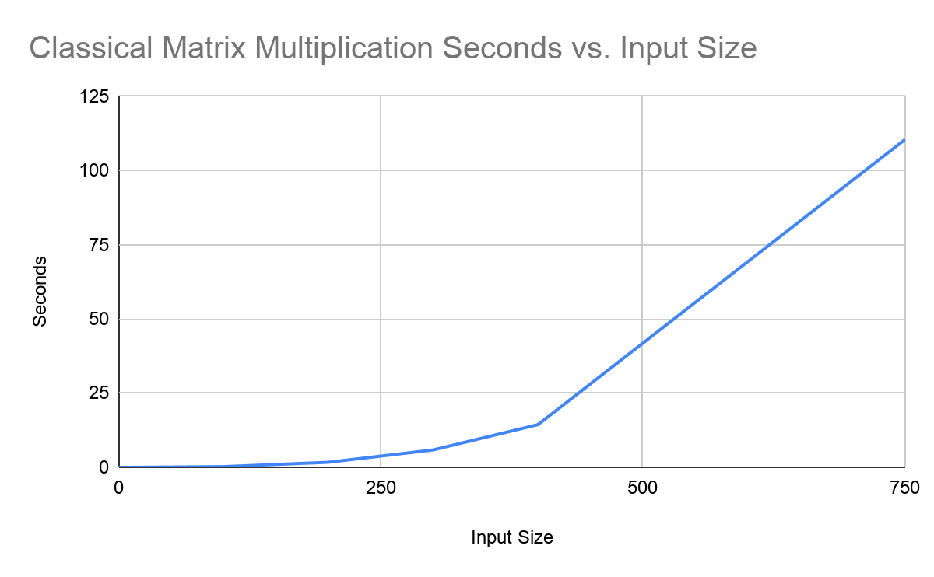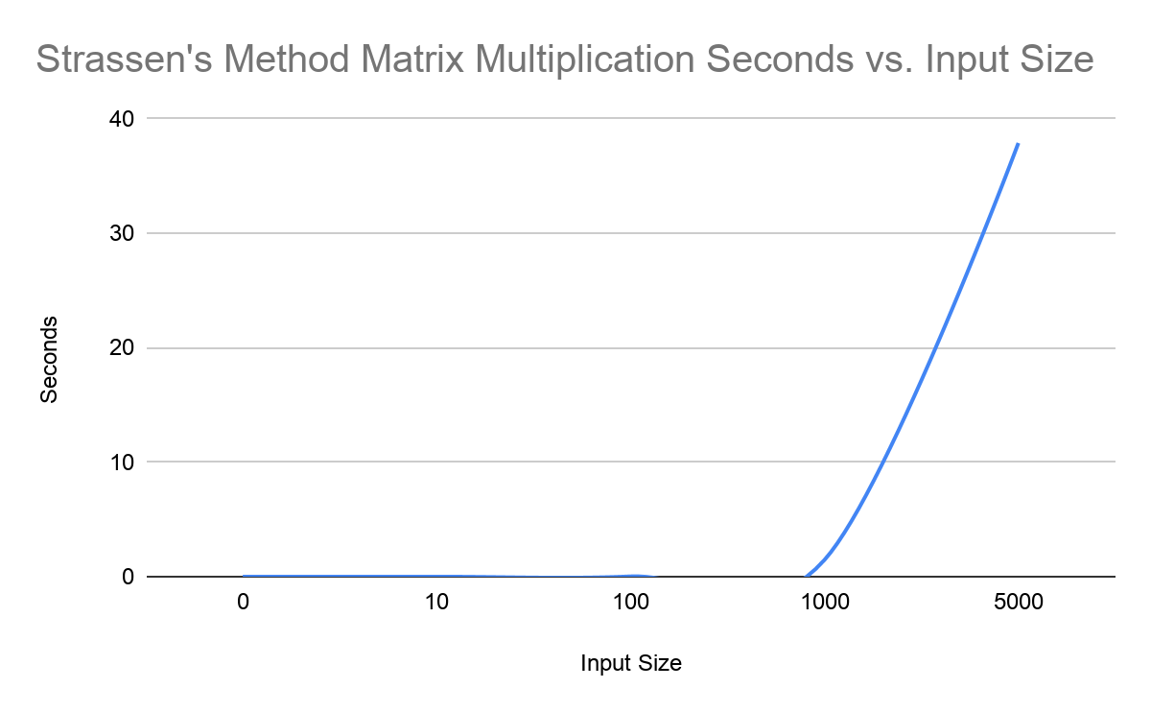
The disparity between the two algorithms here is far greater than that of our sorting algorithms. Because of the reduction in total operations we can see our theoretical efficiency lines up with the actual efficiency. Where our classical matrix multiplication suffers at around an input size of 1,000 the Strassen’s method far outperforms at the same input size and even continues to outperform until it also takes upwards of 20 seconds at roughly double the input size that classic matrix multiplication does.

